**Cloud Computing, Spring 2019**

**Assignment-3**

Kolluru Pradeepika Student id : 16283597 [pk6mh@mail.umkc.edu](mailto:pk6mh@mail.umkc.edu)

Since my system becomes very slow after downloading Sandbox, I completed the assignment using Microsoft Azure.

Step-1 : Created Virtual Machine in Microsoft Azure and named it as “Sample”

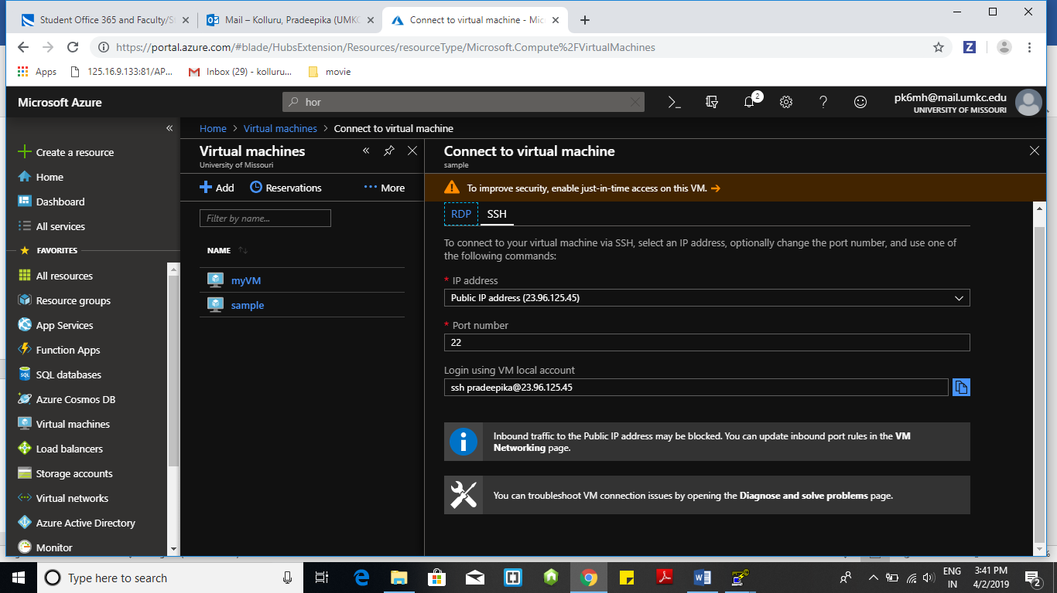

Step-2 : Connected Virtual Machine



Step-3 : Connected to Putty using the private key which is generated by PuttyGen

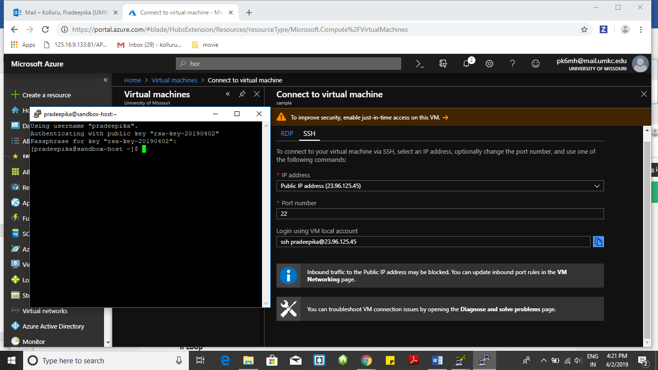

Step-4: Ambari is opened in local host

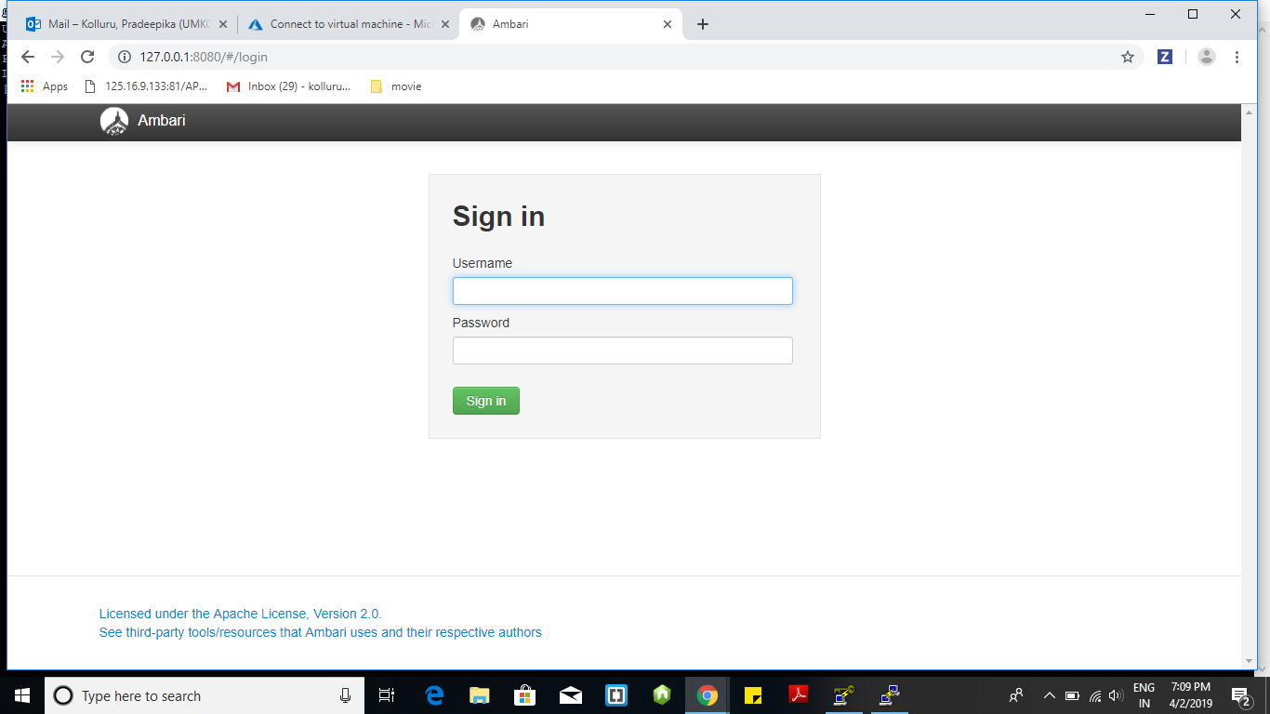

Step-5: Signed-in to Ambari with username : maria_dev and password

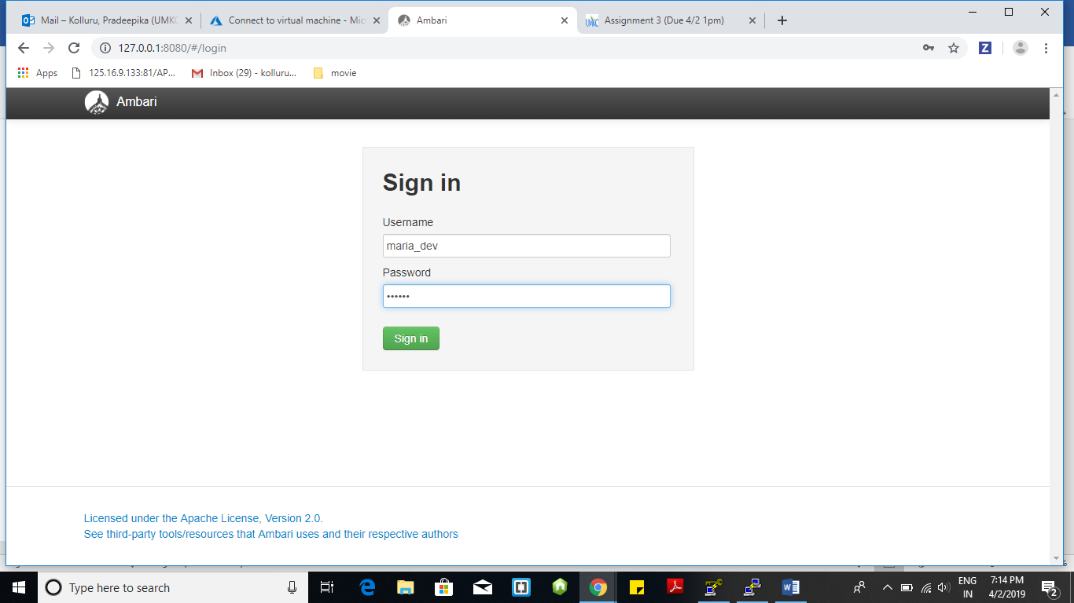

Step-6 : Ambari Home page

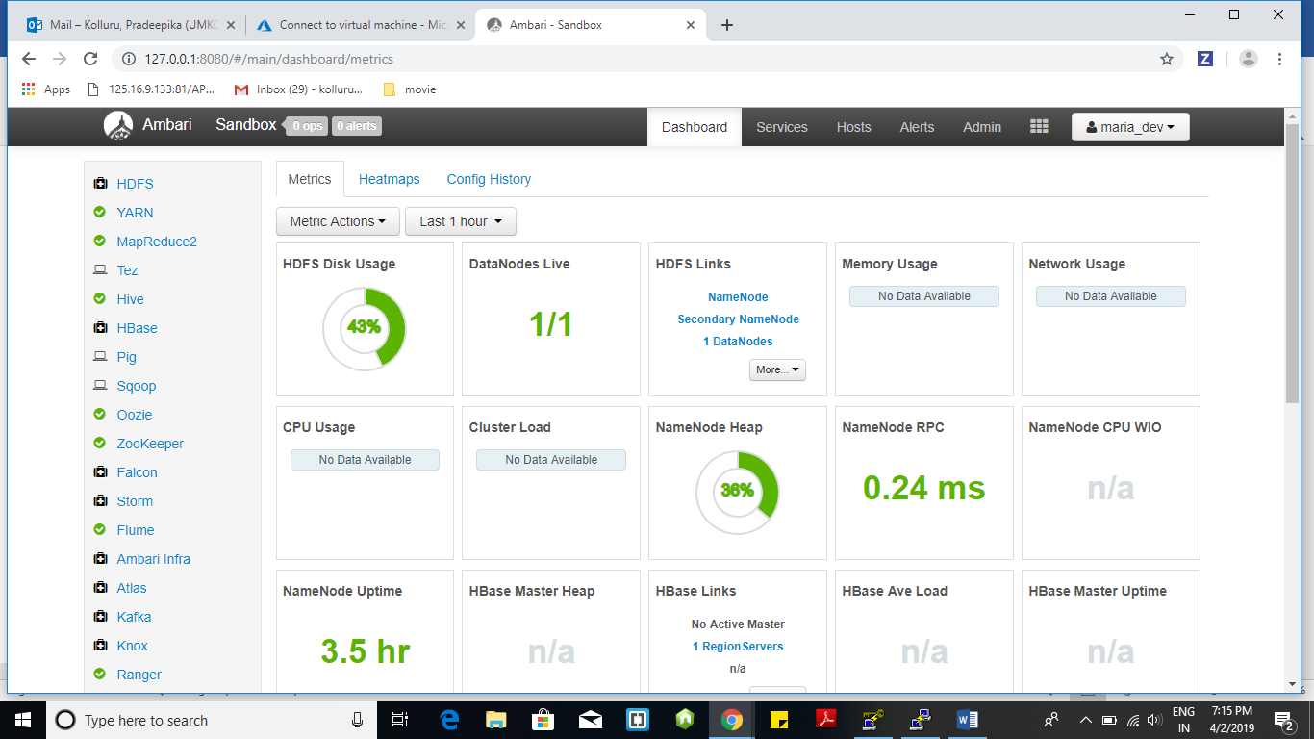

Step -7 : Connected putty again and performed tunneling. Resetting of Admin password is done.

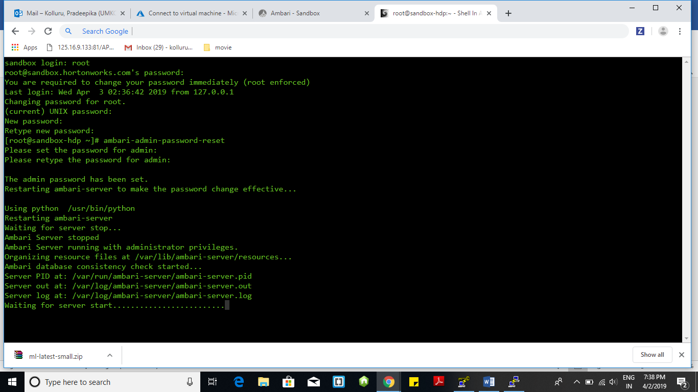

Step -8 : After resetting of Admin password again logged-in to the Ambari with admin as username and changed password is used. Now “Add service” button is enabled .

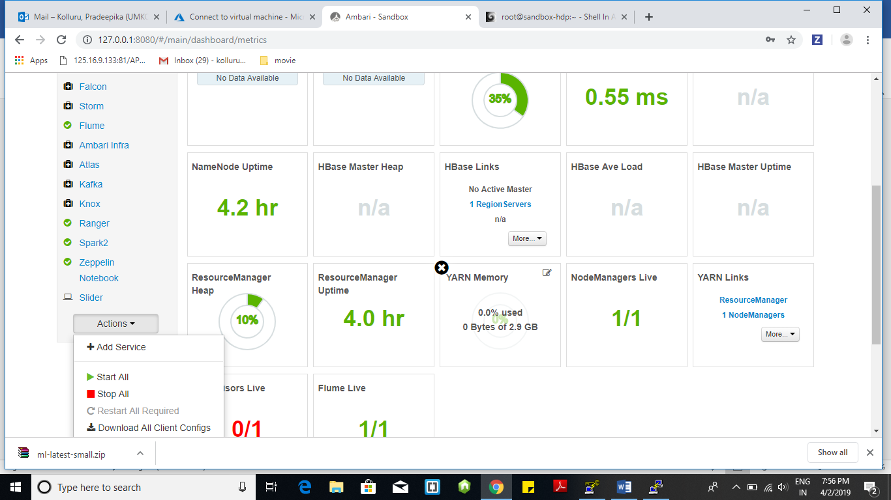

Step-9 : Wizard showing list of all services available.

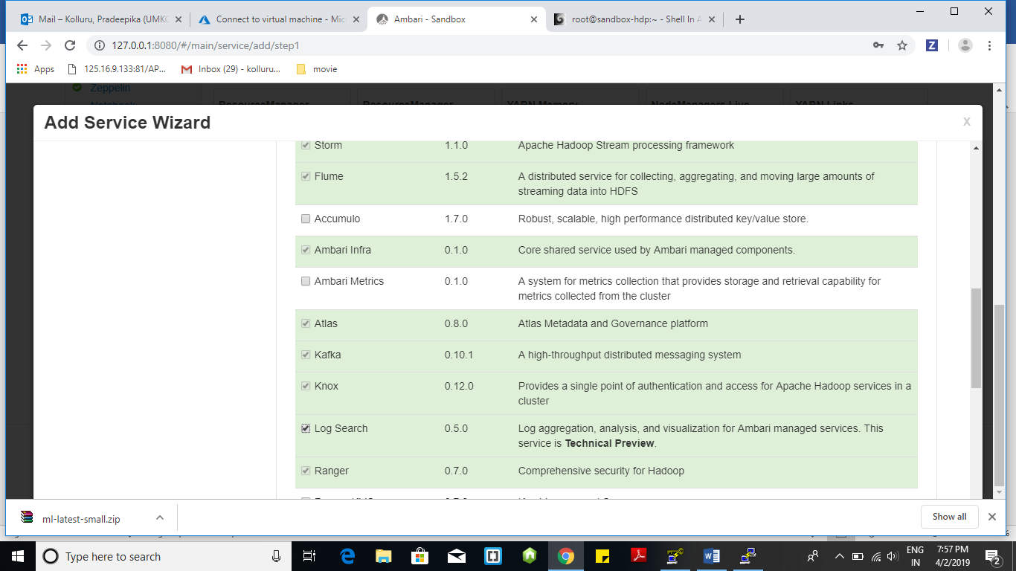

Step-10 : Added “Log Service “

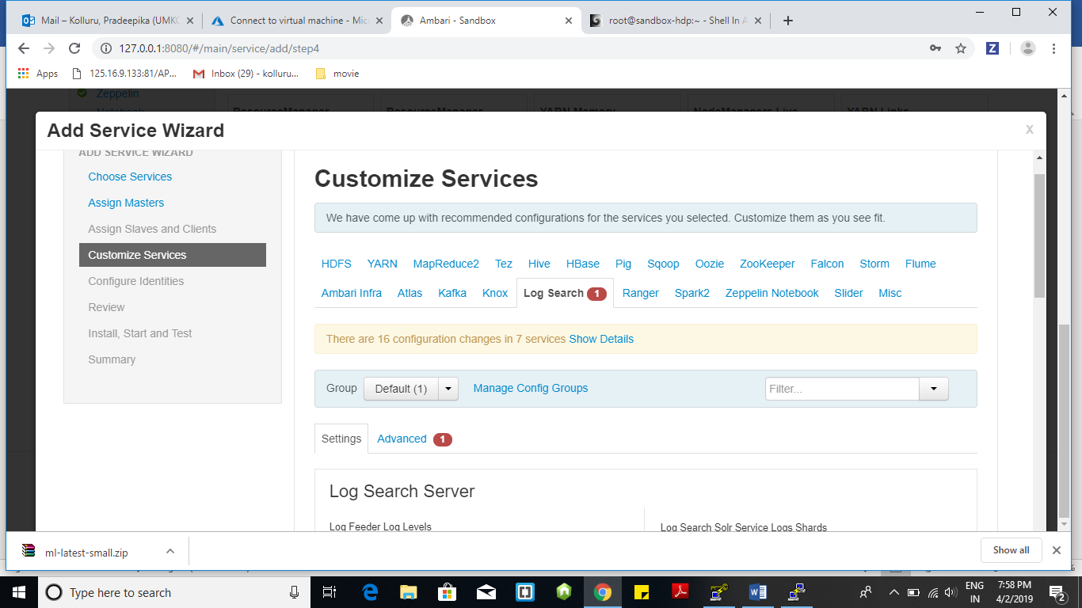

Step-11 : Window showing configurations

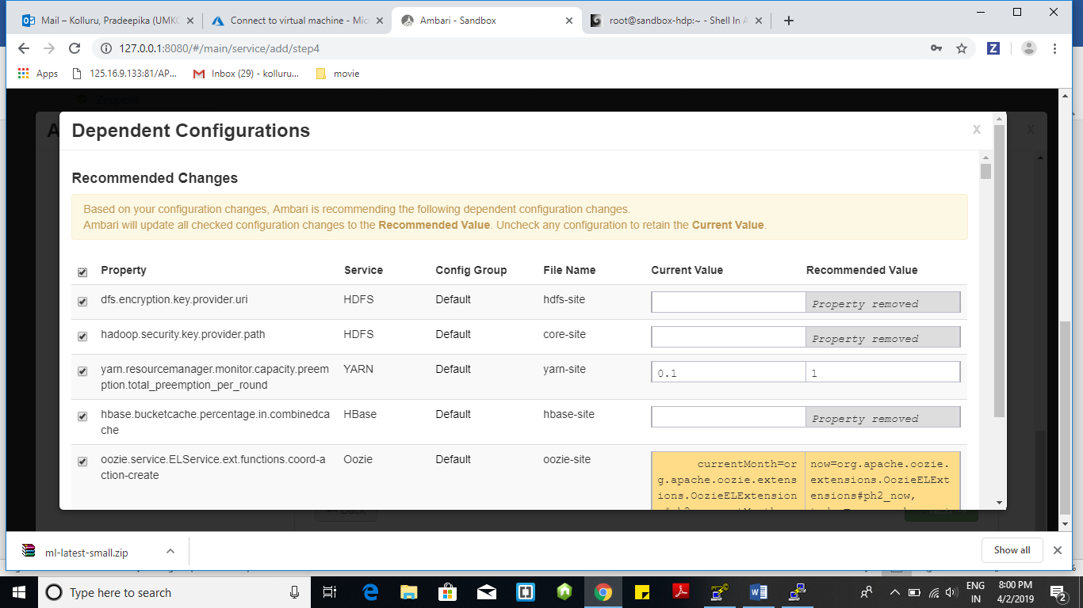

Step-12 : After checking all configurations clink on “Proceed Anyway”

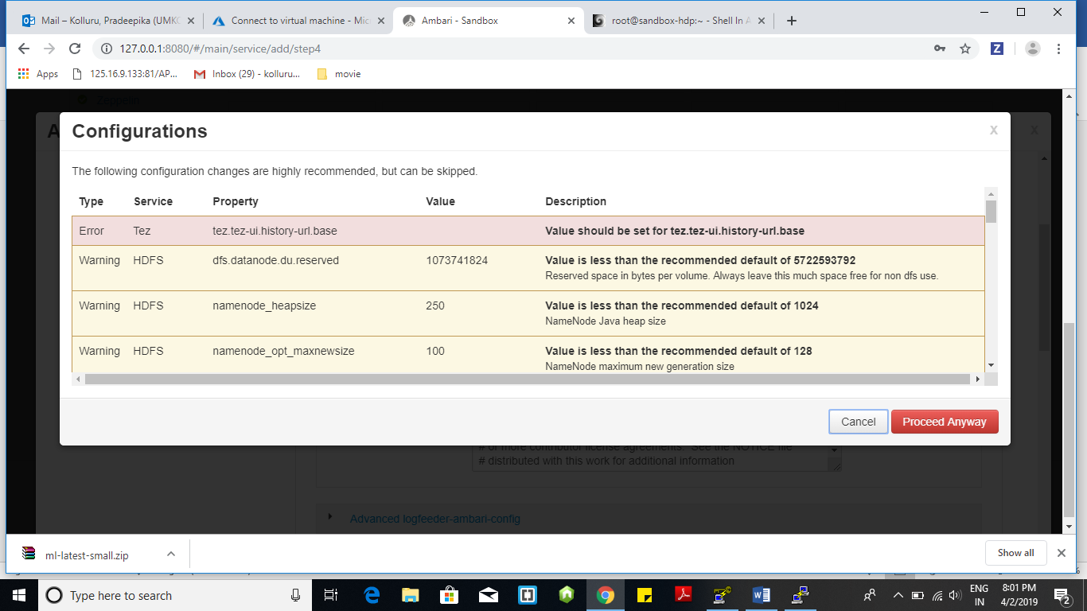

Step-13 : Reviewing the configuration before installing.

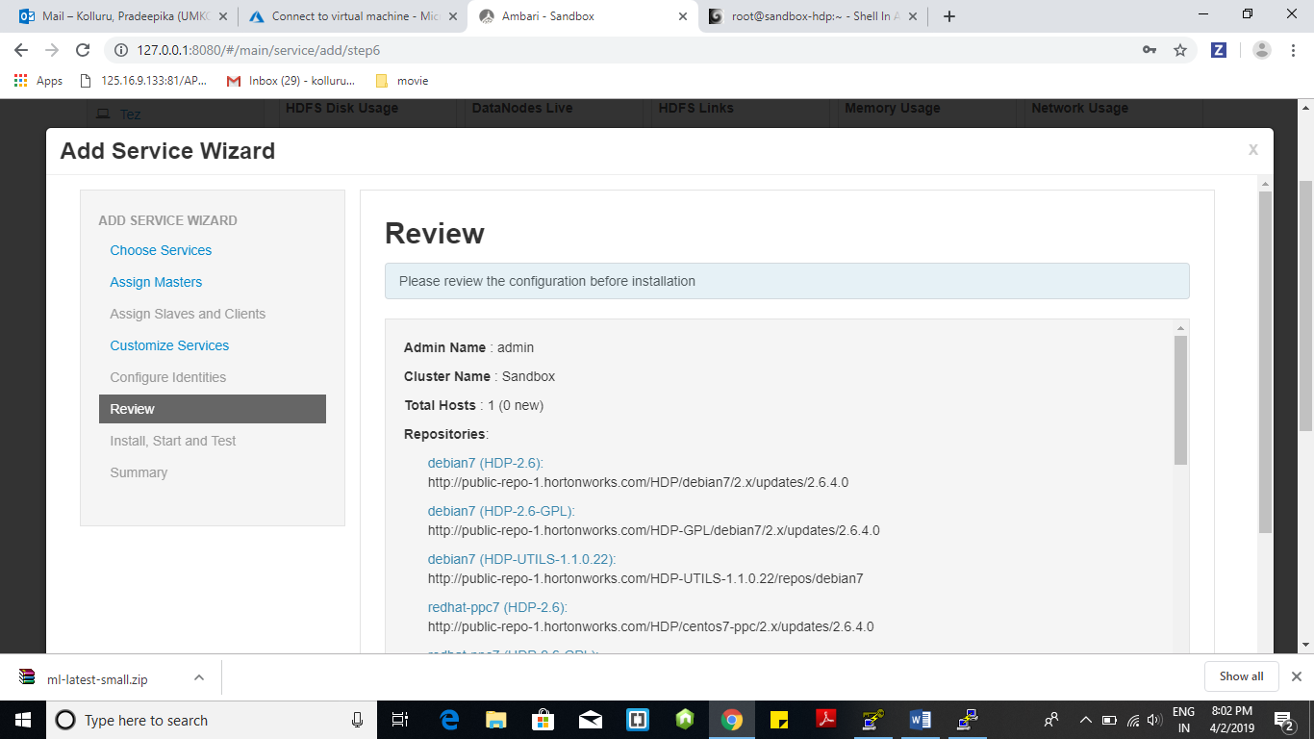

Step-14 : Deploying the service

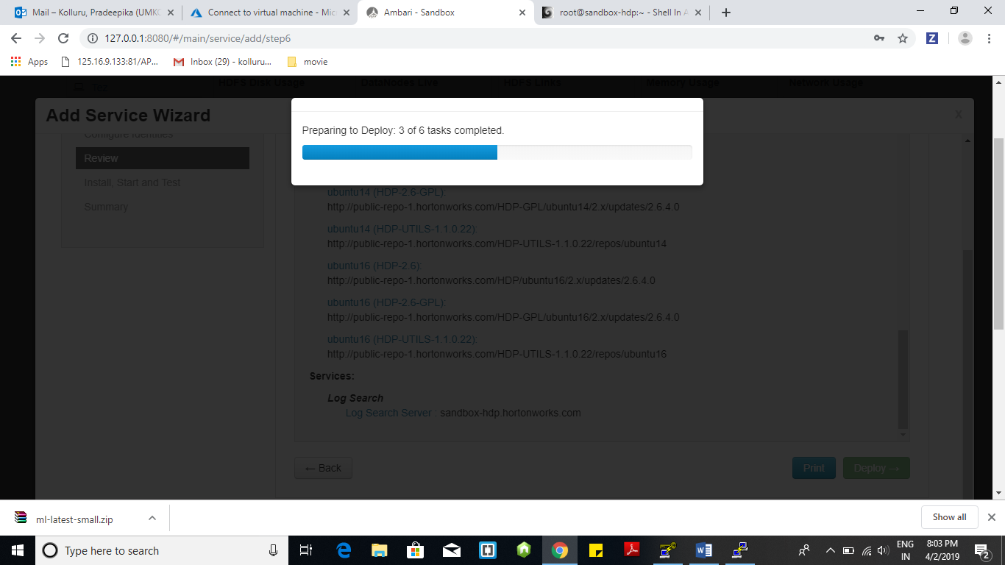

Step-15 : Wait until the selected services are installed and started .

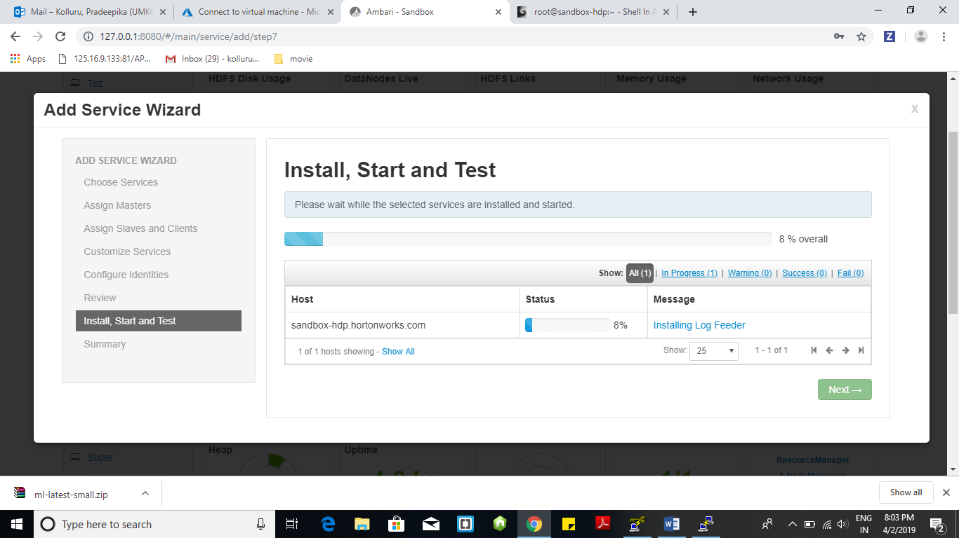

Step -16 : Window showing summary of added “Log service”.

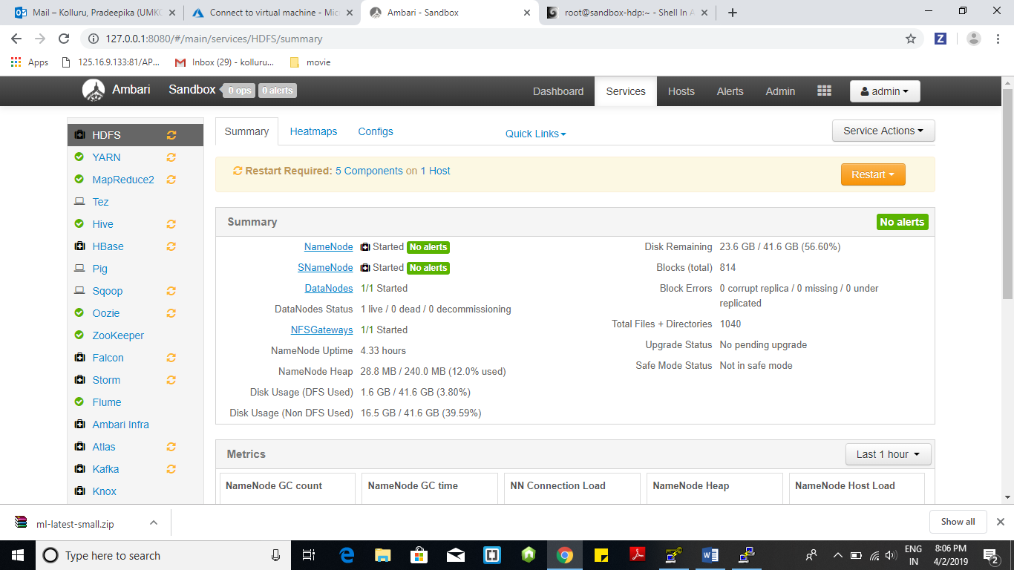

Step-17 : Screenshot showing list of all alerts

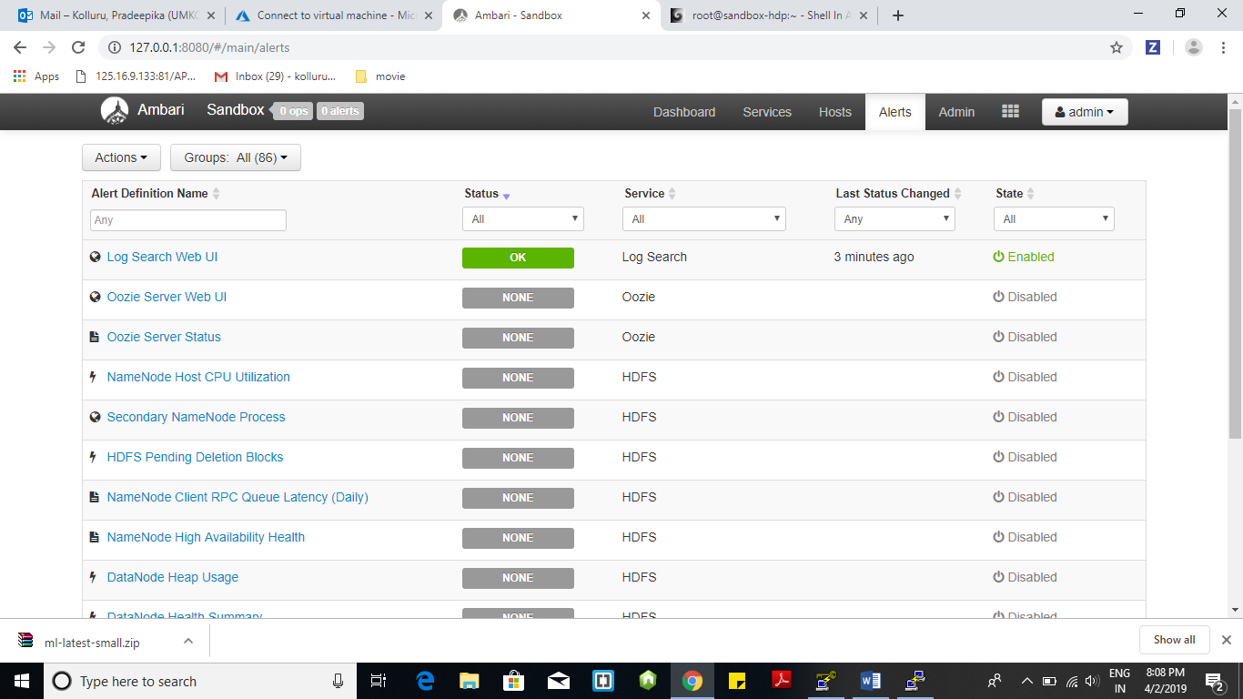

Step-18 : Oozie server status

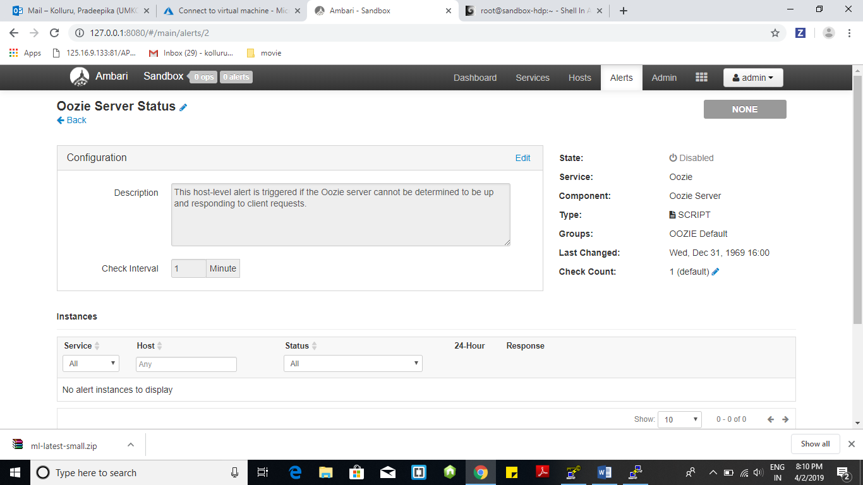

Step-19 : Changed configurations of NameNode Host CPU utilization

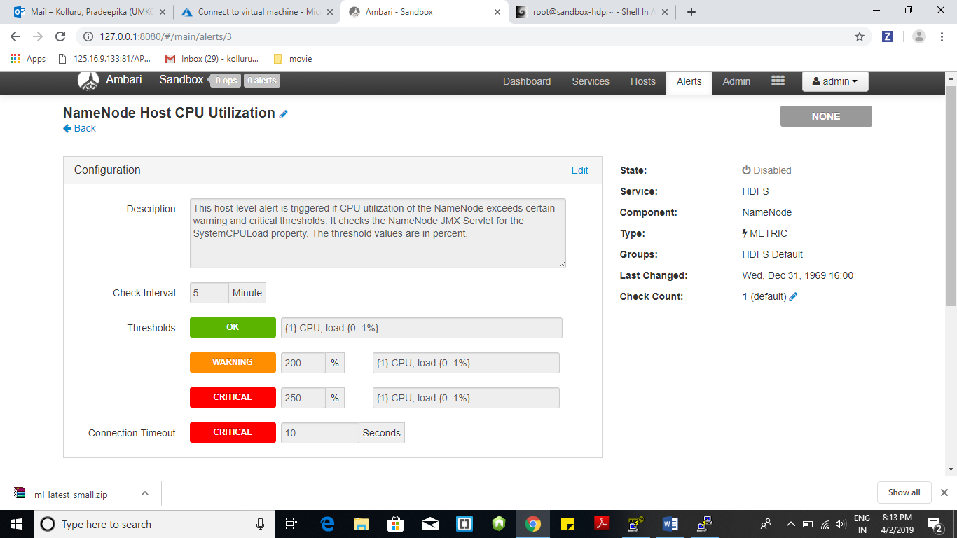

Step-20 : Changed Connection Timeout to 10 sec in Name Node High Availability Health

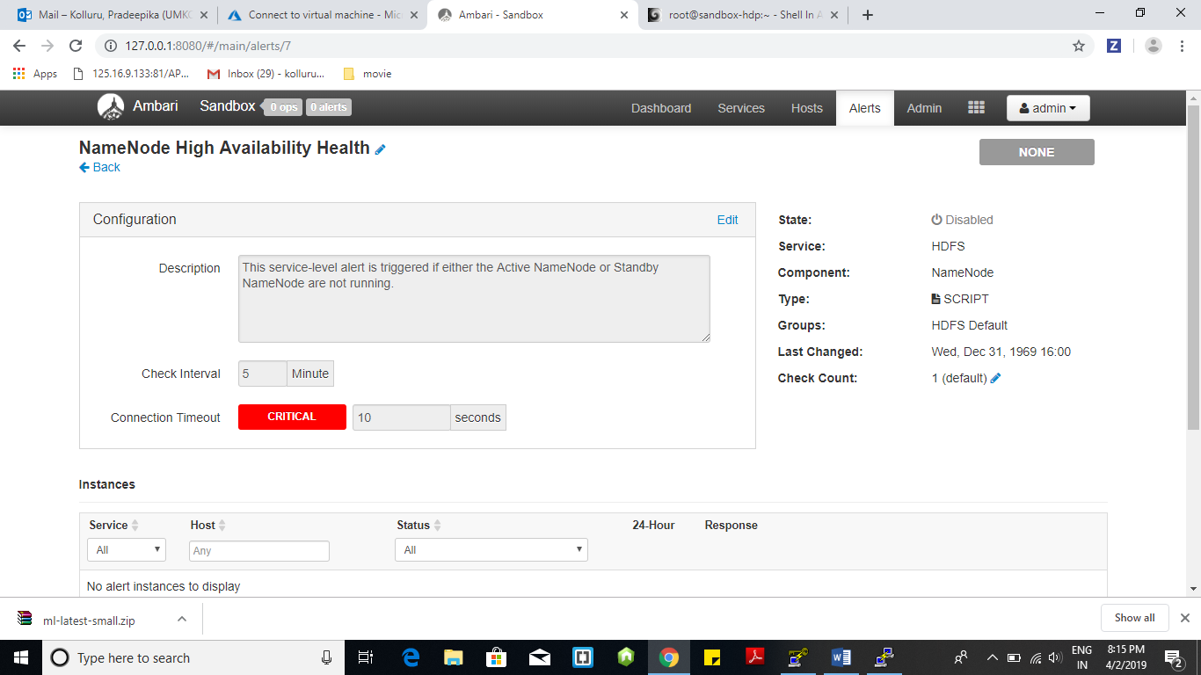

Step-21 : Loaded ratings.csv file and opened PIG INSTANCE and written pig script of displaying top 5 movies based on rating.

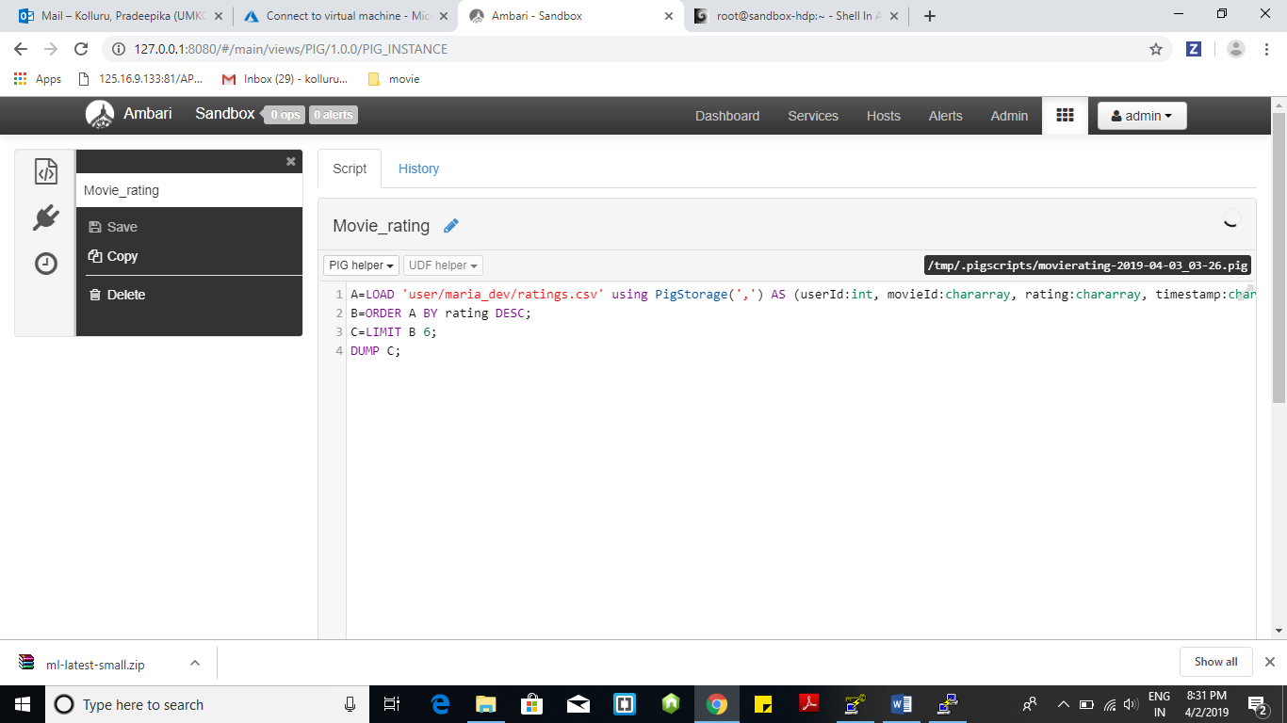

Step-22 : Pig query is executed successfully and the result is displayed in the result tab

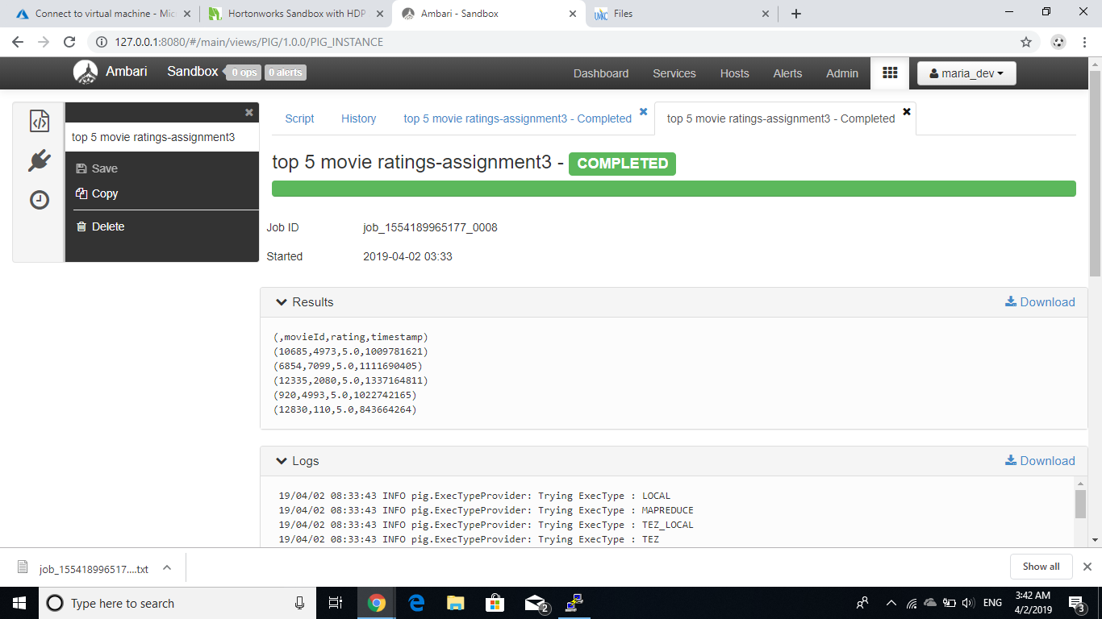

Step-23 : Running the same script on Tez.

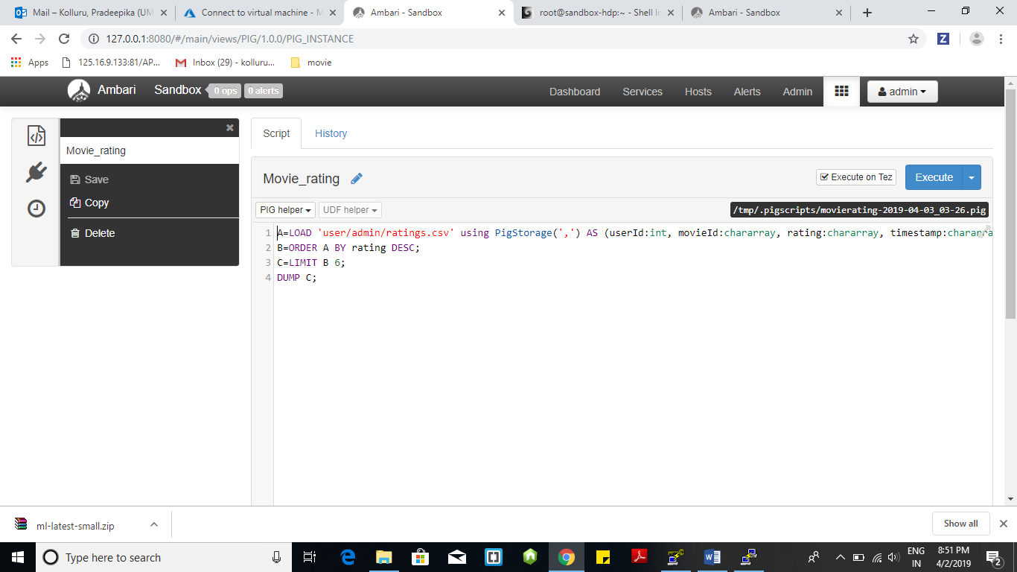

Step -24 : Screenshot showing output of Tez.

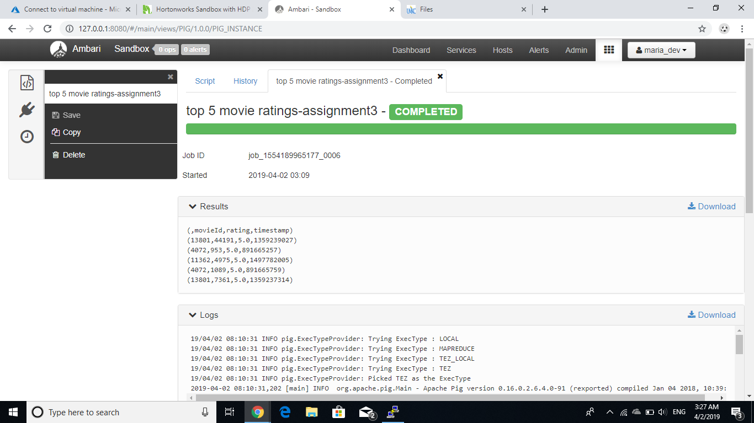

Observations : Downloading and installing of sandbox on local system is consuming more time and space. According to me it is better to use cloud for these operations. One more point I observed is running the script file on Tez took more time when compared to normal exection.